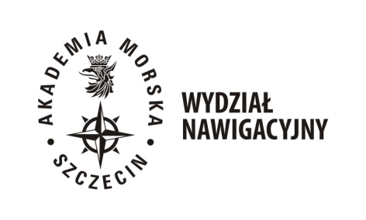

WYDZIAŁOWE CENTRUM KSZTAŁCENIA  
  
ul. Wały Chrobrego 1/2 70-500 Szczecin

Tel. (+4891)48 09 390

[l](mailto:l)e-mail ck.wn@am.szczecin.pl

pasek

FIELD OF STUDY NAVIGATION  
 Retaking a course unit or units

All students who obtained the Dean’s decision on the right of retake a course unit are obliged to:

1 / participate in additional classes, if they are appointed,

2 / report to designated teachers who will define the conditions and method of settling the subject.

|  |  |  |
| --- | --- | --- |
| Course unit | Semester | Teacher responsible for retake course unit |
| Physical education | semesters 2, 3, 4 | mgr inż. Jakub Chuta  j.chuta@am.szczecin.pl |
| Mathematics | semester 3 | dr Anna Pańka  a.panka@am.szczecin.pl |
| Physics | semester 1 | dr Bogdan Bieg  b.bieg@am.szczecin.pl |
| Introduction to Maritime Sociology | semester 3 | dr Sylwester Kowalski  s.kowalski@am.szczecin.pl |
| Safety of Navigation | semester 3 | mgr inż. kpt. ż.w.  Jarosław Poniedziałek  j.poniedzialek@am.szczecin.pl |
| Technical Fleet Operation | semester 3 | mgr inż. Krzysztof Opiela  k.opiela@am.szczecin.pl |
| Navigation | semester 3 | dr inż. kpt.ż.w. Andrzej Bąk, prof. AMS  a.bak@am.szczecin.pl;  mgr inż. Anna Anczykowska  a.anczykowska@am.szczecin.pl |
| Meteorology and Oceanography | semester 3 | dr P. Medyna  p.medyna@am.szczecin.pl |
| Aids to Navigation | semester 2 | dr inż. Stefan Jankowski  s.jankowski@am.szczecin.pl |